PUNE INSTITUTE OF COMPUTER TECHNOLOGY

DHANKAWADI, PUNE – 43

CLASS: FE (COMMON) SUBJECT: BXE

EXPT. NO. : 09 DATE:

TITLE : BUILD AND TEST SIMPLE ELECTRONICS APPLICATION CIRCUIT.

.

OBJECTIVE : Build and Test any Circuit using

1) OP-AMP LM-741.
2) BJT/MOSET
3) Any Digital Logic Gate IC
4) Sensor

APPARATUS : As per your application Circuit.
- Digital Multimeter
- CRO
- Function Generator
THEORY :

- INTRODUCTION:

A Metal Detector is a device which detects the presence of metals nearby. Metal detectors are useful for finding metal inclusions hidden within objects, or metal objects buried underground. The simplest form of a metal detector consists of an oscillator producing an alternating current that passes through a coil producing an alternating magnetic field. If a piece of electrically conductive metal is close to the coil, eddy currents will be induced in the metal, and this produces a magnetic field of its own. If another coil is used to measure the magnetic field (acting as a magnetometer), the change in the magnetic field due to the metallic object can be detected.

- WORKING:
Whenever some current passes through the coil, it generates a magnetic field around it. And the change in the magnetic field generates an electric field. Now according to Faraday's law, because of this Electric field, a voltage develops across the coil which opposes the change in magnetic field and that’s how Coil develops the Inductance, means the generated voltage opposes the increase in the current.
When any metal comes near to the coil then coil changes its inductance. This change in inductance depends upon the metal type. It's decreases for non-magnetic metal and increases for ferromagnetic materials like iron. Depending on the core of the coil, inductance value changes drastically.
We are using a capacitor which is charged by the rising pulse or spike. It required few pulses to charge the capacitor to the point where its voltage can be read by Arduino Analog pin A5. Then Arduino reads the voltage of this capacitor by using ADC. After reading voltage, capacitor quickly discharged by making capPin pin as output and setting it to low. This whole process takes around 100 microseconds to complete. For better result, we repeat measurement and took an average of the results. That’s how we can measure the approximate inductance of Coil. After getting the result we transfer the results to the LED and buzzer to detect the presence of metal. As charge is stored in the inductor it takes time for it to lose the gained potential. This is the reason why the delay is seen.
For example: in old TVs as inductors were used we could see the led light glow for some time even if the Tv is switched off.

- SPECIFICATION OF COMPONENTS
Sr. No. | Name of the Component | Parameter/values
1. | Arduino Nano | Micro-Controller
2. | Resistor | 1k Ohm, 330 Ohm
3. | Capacitor | 10nF
4. | LED | Green Color
5. | Zener Diode | 1N4148
6. | Copper Coil | Inductance
7. | Buzzer | Audio Signalling

- CIRCUIT DIAGRAM WITH COMPONENT VALUE

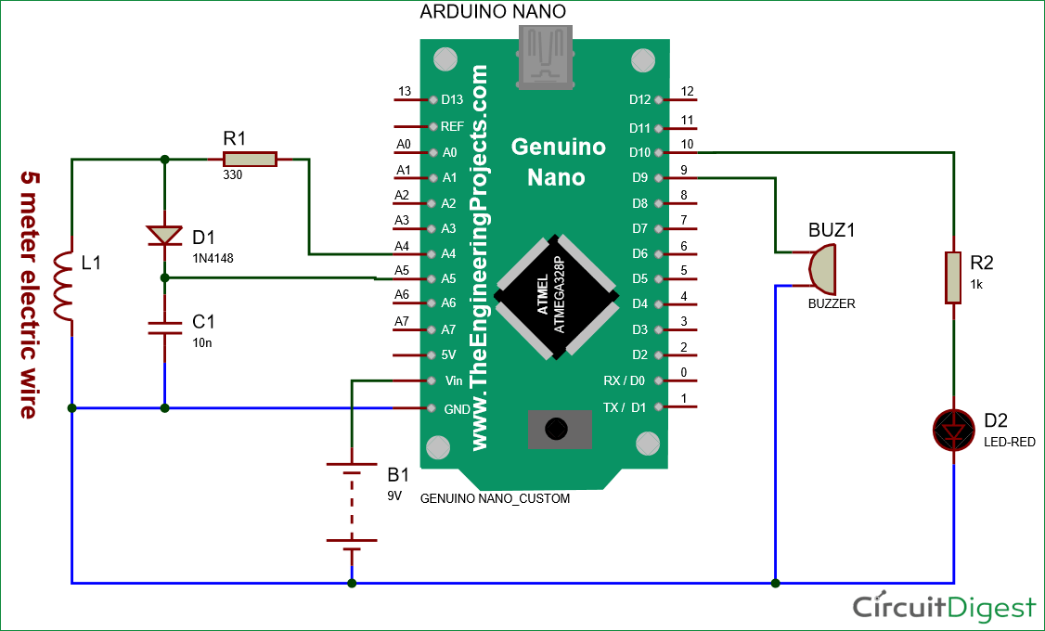

- APPROXIMATE COST:

Sr. No | Components | Cost (₹)
1. | Arduino Nano | 180
2. | Resistors (1k Ohm & 330 Ohm) | 2
3. | Capacitor (10nF) | 1
4. | LED | 1
5. | Zero Type PCB | 50
6. | Zener Diode (1N4148) | 1
7. | Buzzer | 10
8. | Coil | 5
Total Cost |  | 250

PROCEDURE:
- We do the connections on the Arduino Nano according to the circuit diagram.
- Code:

#define capPin A5
#define buz 9
#define pulsePin A4

#define led 10

long sumExpect=0; //running sum of 64 sums
long ignor=0; //number of ignored sums
long diff=0; //difference between sum and avgsum
long pTime=0;
long buzPeriod=0;

void setup()
{
Serial.begin(9600);
pinMode(pulsePin, OUTPUT);
digitalWrite(pulsePin, LOW);
pinMode(capPin, INPUT);
pinMode(buz, OUTPUT);
digitalWrite(buz, LOW);
pinMode(led, OUTPUT);
}

void loop()
{
int minval=1023;
int maxval=0;
long unsigned int sum=0;
for (int i=0; i<256; i++)
{
//reset the capacitor
pinMode(capPin,OUTPUT);
digitalWrite(capPin,LOW);
delayMicroseconds(20);
pinMode(capPin,INPUT);
applyPulses();

//read the charge of capacitor
int val = analogRead(capPin); //takes 13x8=104 microseconds
minval = min(val,minval);
maxval = max(val,maxval);
sum+=val;

long unsigned int cTime=millis();
char buzState=0;
if (cTime<pTime+10)
{
if (diff>0)
buzState=1;
else if(diff<0)
buzState=2;
}
if (cTime>pTime+buzPeriod)
{
if (diff>0)
buzState=1;
else if (diff<0)
buzState=2;
pTime=cTime;
}
if (buzPeriod>300)
buzState=0;

if (buzState==0)
{
digitalWrite(led, LOW);
noTone(buz);
}
else if (buzState==1)
{
tone(buz,2000);
digitalWrite(led, HIGH);
}

else if (buzState==2)
{
tone(buz,500);
digitalWrite(led, HIGH);
}
}

//subtract minimum and maximum value to remove spikes
sum-=minval;
sum-=maxval;

if (sumExpect==0)
sumExpect=sum<<6; //set sumExpect to expected value
long int avgsum=(sumExpect+32)>>6;
diff=sum-avgsum;
if (abs(diff)<avgsum>>10)
{
sumExpect=sumExpect+sum-avgsum;
ignor=0;
}
else
ignor++;
if (ignor>64)
{
sumExpect=sum<<6;
ignor=0;
}
if (diff==0)
buzPeriod=1000000;
else
buzPeriod=avgsum/(2*abs(diff));
}

void applyPulses()
{
for (int i=0;i<3;i++)
{
digitalWrite(pulsePin,HIGH); //take 3.5 uS
delayMicroseconds(3);
digitalWrite(pulsePin,LOW); //take 3.5 uS
delayMicroseconds(3);
}
}

- Upload the code to the Arduino Microcontroller and attach power supply (i.e 9V battery) in order to run the circuit.
CONCLUSION:
We were able to implement the electrical components to successfully build a Metal
Detector using an Arduino Microcontroller along with other electronic components.

Teacher Sign with Date Remark
REFERENCE : 1. Circuitdigest.com
2. Wikipedia
3. Google
4. YouTube

